**U of RPG**

**Meliora - Online**

**V2.1**

**BY**

Bradley Beyers - Head of AI; Active in Framework & Backend

Alex Hankin - Author and Co-Head of Art

Santiago Loane – Head of Art

Aaron McClure - Head of UI; Active in Animation & Framework

Graeme McGuire

Jacob Niebloom - Head of Backend & Music; Active in Framework

Naropa Perez - Head of Animation; Active in Framework

Hayden Shiff - Active in User Interface

**11/5/2014**

**Revised Proposal (Revised Version)**

This proposal’s purpose is to serve as follow-up to our previous revised proposal and the comments received. Upon receiving the comments of our revised proposal, the U of RPG project group realized that we were unaware of what was expected of us for our revised proposal, and have decided to write a fully revised proposal where we provide fresh corrections and an updated look at the size and scale we want our project to have. We apologize for the misunderstanding when writing our previous revisions

**Groups**

**Animation**

Lorem ipsum dolor sit amet.

**Framework**

Lorem ipsum dolor sit amet.

**User Interface**

Lorem ipsum dolor sit amet.

**Backend**

Lorem ipsum dolor sit amet.

**AI/Enemy**

Lorem ipsum dolor sit amet.

**Art**

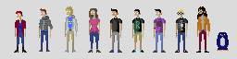Art has been going very smoothly. Two members of our team have been consistently working on aspects of art. One member has made considerable progress on our sprites as shown in our previously submitted proposal:

Our other art team member has recently completed a basic terrain-filled overworld map using around 65 original tiles, and will be implemented into our website shortly.

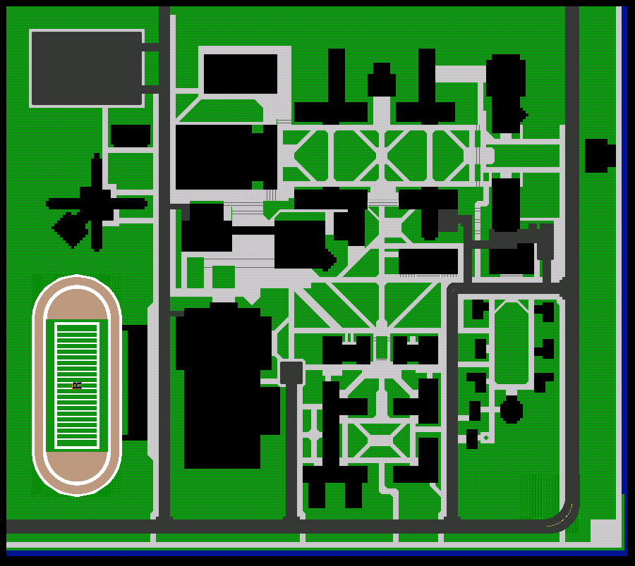

Art for us is clearly not an issue. We have been able to produce sprites efficiently, and we believe animation will not be too difficult because of the simplistic style of the sprites. We have shown that we are capable of map editing and can create enough locations and tiles to meet our project needs.

**Plot**

Plot is currently not one of our main priorities, as the plot will need to wait until we have completed the final framework of our project. We have currently begun reworking what we are capable of in the time given. While plot will definitely not be a “last-minute addition” we have decided to wait until the finalization of our Mechanics and our Framework.

**Music**

Lorem ipsum dolor sit amet.

**Progression**

Lorem ipsum dolor sit amet.